**DELHI TECHNOLOGICAL UNIVERSITY**

(Formerly Delhi College of Engineering)

Bawana Road, Delhi, 110042



Department of Computer Science & Engineering

Easing life of Economic Weaker Section with Modern Techniques

Submitted by-

Abhishek Kumar 2K19/CO/020

Abhishek Kumar Singh 2K19/CO/021

Date: 02/11/2021

Submitted to-

Prof. Seema Dwivedi

**DELHI TECHNOLOGICAL UNIVERSITY**

(Formerly Delhi College of Engineering)

Bawana Road, Delhi, 110042

**CANDIDATE’S DECLARATION**

We, Abhishek Kumar, Abhishek Kumar Singh Roll No(s). 2K19/CO/020, 2K19/CO/021, students of B.Tech. in Computer Science & Engineering, hereby declare that the project Dissertation titled **Easing life of Economic Weaker Section with Modern Techniques** which is submitted by us to the Department of Computer Science & Engineering, Delhi Technological University, Delhi in partial fulfillment of the requirement for the award of the mid-semester component evaluation, semester-5 of Bachelor of Technology is original and not copied from any source without proper citation. This work has not previously formed a basis for the award of any degree, Diploma Associateship, Fellowship, or any similar title or recognition.

Place: Delhi                                                                                 Abhishek Kumar

Date: 02/11/2021                                                 Abhishek Kumar Singh

**DEPARTMENT OF COMPUTER SCIENCE & ENGINEERING**

DELHI TECHNOLOGICAL UNIVERSITY

(Formerly Delhi College of Engineering)

Bawana Road, Delhi, 110042

**CERTIFICATE**

We hereby declare that the project Dissertation titled “**Easing life of Economic Weaker Section with Modern Techniques”** which is submitted by Abhishek Kumar, Abhishek Kumar Singh Roll No(s). 2K19/CO/020, 2K19/CO/021 Department of Computer Science & Engineering, Delhi Technological University, Delhi in partial fulfilment of the requirement for the award of the mid-semester component evaluation, semester-5 of Bachelor of Technology, is the record of the project work carried out by the students under my supervision.

Place: Delhi   **Prof. Seema Dwivedi**

Date:  02/11/2021                       Delhi Technological University

(Formerly DCE)

Bawana Road, Delhi,110042

**ACKNOWLEDGEMENT**

At the very outset of this report, we would like to extend our sincere and heartfelt obligation towards all the personages who have guided us with the project.

A special thanks to **Prof. Seema Dwivedi** for teaching us the subject “Engineering Economics”. She helped us visualize the subject and to find its applications in real life. She supervised us with the intricacies of this project. She also offered many relevant and productive recommendations for the project, for which we are very grateful. We would also like to extend sincere gratitude towards our Vice-Chancellor for allowing the students to improve their theoretical and practical skills with practical and crucial subjects like Engineering Economics.

INTRODUCTION

Global extreme poverty rose in 2020 for the first time in over 20 years as the disruption of the COVID-19 pandemic compounded the forces of conflict and climate change, which were already slowing poverty reduction progress. About 100 million additional people are living in poverty as a result of the pandemic.

Slum can be defined as a residential area where dwellings are unfit for human habitation by reasons of dilapidation, overcrowding, lack of ventilation or sanitation facility and having drinking water facilities in unhygienic conditions. It’s so ironical that slums are the abode of lakhs of people whose work makes the lives of better-off citizens easier and comfortable but they themselves are forced to live in worst of conditions. They don’t even have access to a basic need like functional toilets, breeding indignity and infections in their daily lives.

**Causes of the formation of slums:**

* Increasing population
* Increasing rural to urban migration. Poverty and lack of job opportunities in rural areas are the push factors of migration.
* Poor planning of cities. Urban areas are not being improved enough to accommodate the new inhabitants.
* The high cost of living in urban areas.
* Natural disasters
* Social exclusion
* Informal economy

**Current Situation of Slums:**

* Lack of medical facilities
* Lack of electricity
* Miserable Toilets
* Lack of sanitation
* Congested
* No access to drinking water
* No proper drainage system

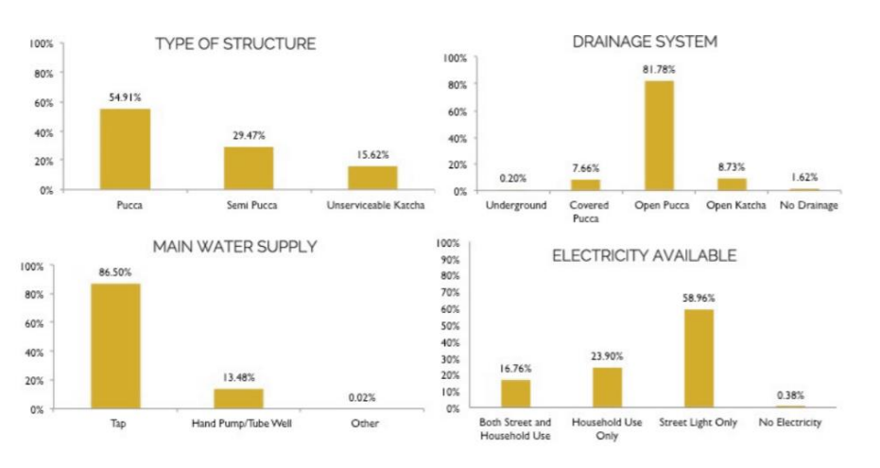

Slum Characteristics (Infrastructure and Services)

People living in the slums lack many fundamental amenities. Whereas 55% live in structures that have walls and ceilings of pucca materials (concrete or cement), 30% of slum dwellers live in structures that have either walls or ceilings of pucca materials, but not both. Furthermore, 15% of slum dwellers live in structures that are made with less durable materials (grass, plastic, cardboard, etc.). Homes with pucca materials may represent greater investment by slum dwellers as well as greater perceived stability, as they are harder to remove or modify. Most slum dwellers do not have access to electricity in their homes. Additionally, the drainage and water systems also show deficiencies. Similarly, only 32% of the slums had an arrangement for the disposal of garbage organized by local bodies, with the remaining 68% having the arrangement made by the residents themselves or some other type of arrangement.

**Dharavi slum area**

**Garbage & Filth:** We could see dumps of garbage everywhere. The dumped waste emanates foul odour and at the same time becomes breeding ground for flies and mosquitoes which carry several diseases with them.

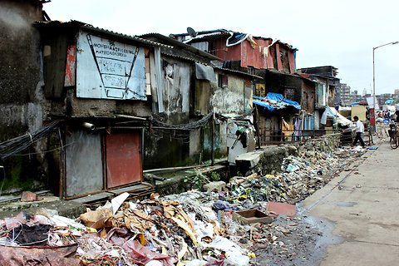

**Miserable Toilets:** The community toilets are in pathetic conditions. Plenty of them have no doors and the ones that have doors have no latches. Toilets are full of filth and human excreta as water supply through pipes are not working.

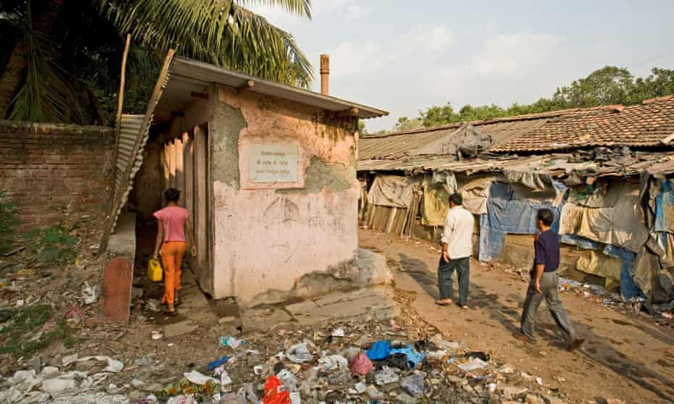

**Effects on the people living in slums:**

* The reduced life expectancy of slum inhabitants.
* Degraded health conditions
* Environment pollution
* The low standard of living
* Slums inhabitants will become the worst victims of natural disasters.
* Slums breed violence, crime, diseases, epidemics and psychological illnesses.
* Malnutrition in children
* Child labour

These deficiencies indicate that there is a need for more investments to provide basic infrastructure if slums are to become dignified habitable spaces. However, the precarious nature of the slums disincentivizes people to make the necessary investments to improve the quality of their dwellings.

OBJECTIVE

Currently, more than half of the world’s population lives in cities. Out of these more than four billion people, almost one quarter live in slums or informal settlements. In order to improve living conditions, we provide possible solutions for the major problems in slums. In this project we have shown the various application of solar energy in the form of solar chimneys, solar domes and passive cooling which can prove to be a substantial help in improving slum life at a low cost. These techniques are used at a low scale in countries like India and Portugal, but they have a potential to serve a much larger scale especially in tropical and sub-tropical countries.

SOLAR CHIMNEY

A solar chimney – often referred to as a thermal chimney – is a way of improving the natural ventilation of buildings by using convection of air heated by passive solar energy. A simple description of a solar chimney is that of a vertical shaft utilizing solar energy to enhance the natural stack ventilation through a building. The solar chimney has been in use for centuries, particularly in the Middle East and Near East by the Persians, as well as in Europe by the Romans.

**Benefits regarding use of Solar Chimneys are:**

* Improved ventilation rates on still, hot days
* Reduced reliance on wind and wind driven ventilation
* Improved control of air flow through a building
* Greater choice of air intake (i.e., Leeward side of building)
* Improved air quality and reduced noise levels in urban areas
* Increased night time ventilation rates
* Ventilation of narrow, small spaces with minimal exposure to external element

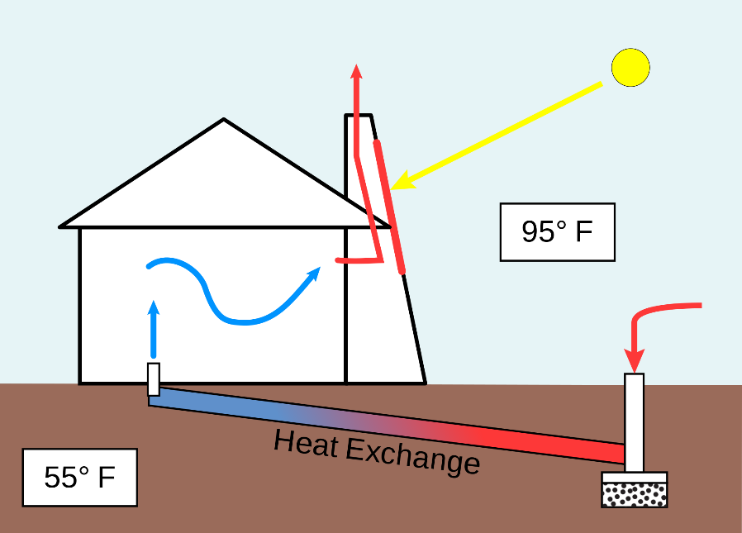**Solar Chimney and Sustainable Architecture**

Solar chimneys, also called heat chimneys or heat stacks, can also be used in architectural settings to decrease the energy used by mechanical systems (systems that heat and cool the building through mechanical means). Air conditioning and mechanical ventilation have been for decades the standard method of environmental control in many building types, especially offices, in developed countries. Pollution and reallocating energy supplies have led to a new environmental approach in building design. Innovative technologies along with bioclimatic principles and traditional design strategies are often combined to create new and potentially successful design solutions.

**Functioning**

A solar chimney can serve many purposes. Direct sunlight warms air inside the chimney causing it to rise out the top and drawing air in from the bottom. This drawing of air can be used to ventilate a home or office, to draw air through a geothermal heat exchange, or to ventilate only a specific area such as a composting toilet.

Natural ventilation can be created by providing vents in the upper level of a building to allow warm air to rise by convection and escape to the outside. At the same time cooler air can be drawn in through vents at the lower level. Trees may be planted on that side of the building to provide shade for cooler outside air.

This natural ventilation process can be augmented by a solar chimney. The chimney has to be higher than the roof level, and has to be constructed on the wall facing the direction of the sun. Absorption of heat from the sun can be increased by using a glazed surface on the side facing the sun. Heat absorbing material can be used on the opposing side. The size of the heat-absorbing surface is more important than the diameter of the chimney. A large surface area allows for more effective heat exchange with the air necessary for heating by solar radiation. Heating of the air within the chimney will enhance convection, and hence airflow through the chimney. Openings of the vents in the chimney should face away from the direction of the prevailing wind.

**Solar Chimney in use**

In hot climates, the urban heat island (UHI) effect tends to increase the local Bowen Ratio, due to the reduction of urban moisture, and thus to also increase the ambient temperature, contributing to the dweller's discomfort.

Both previous roof strategies manage to reduce the indoor temperature, counteracting the UHI temperature effect, although they do not address the need of natural air flow, which is frequently reduced, especially at ground level, by the common densely urban configuration of poor settlements (Arnfield, 2003; Santamouris, 2001).

Several wind and thermal-driven natural ventilation systems have been studied and applied. In this low-budget solutions context, the solar chimney, as a natural ventilation driver, has been studied since late 80s (Bouchair, 1988) and shown to be effective (Bansal, 1994).

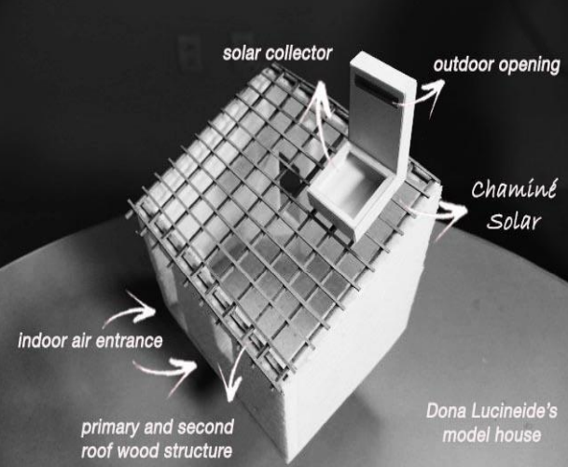

SOLAR DOME

The micro solar dome is a device that can capture sunlight and concentrate it in a gloomy room. It has transformed the lives of around 130 families of the Lal Bagh slum in north Delhi as the amount of light has increased while the electricity bill has dropped.

Because of poor ventilation, sunlight doesn’t enter most of these shanties and the families have to either remain in dark or switch on the bulbs and tubelights even during daytime. But over the past two years a simple innovation known as the Micro Solar Dome (MSD) has transformed the lives of around 130 families in the same slum.

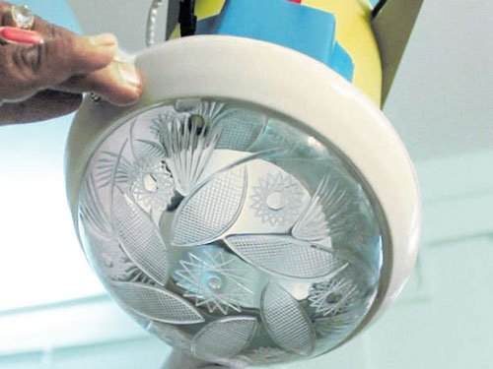

PASSIVE COOLING

Another method that may be used to improve life in the slum is passive cooling. Passive cooling is a building design approach that focuses on heat gain control and heat dissipation in a building in order to improve the indoor thermal comfort with low or no energy consumption. This approach works either by preventing heat from entering the interior (heat gain prevention) or by removing heat from the building (natural cooling). Natural cooling utilizes on-site energy, available from the natural environment, combined with the architectural design of building components (e.g., building envelope), rather than mechanical systems to dissipate heat. Therefore, natural cooling depends not only on the architectural design of the building but on how the site's natural resources are used as heat sinks (i.e., everything that absorbs or dissipates heat). Examples of on-site heat sinks are the upper atmosphere (night sky), the outdoor air (wind), and the earth/soil. Passive cooling covers all natural processes and techniques of heat dissipation and modulation without the use of energy. Some authors consider that minor and simple mechanical systems (e.g., pumps and economizers) can be integrated in passive cooling techniques, as long they are used to enhance the effectiveness of the natural cooling process.

**Types of Passive Cooling**

* **Radiative cooling**

All objects constantly emit and absorb radiant energy. An object will cool by radiation if the net flow is outward, which is the case during the night. At night, the long-wave radiation from the clear sky is less than the long-wave infrared radiation emitted from a building, thus there is a net flow to the sky. Since the roof provides the greatest surface visible to the night sky, designing the roof to act as a radiator is an effective strategy. There are two types of radiative cooling strategies that utilize the roof surface: direct and indirect:

* **Evaporative cooling**

This design relies on the evaporative process of water to cool the incoming air while simultaneously increasing the relative humidity. A saturated filter is placed at the supply inlet so the natural process of evaporation can cool the supply air. Apart from the energy to drive the fans, water is the only other resource required to provide conditioning to indoor spaces. The effectiveness of evaporative cooling is largely dependent on the humidity of the outside air; dryer air produces more cooling.

* **Earth coupling**

Earth coupling uses the moderate and consistent temperature of the soil to act as a heat sink to cool a building through conduction. This passive cooling strategy is most effective when earth temperatures are cooler than ambient air temperature, such as in hot climates.

**Implementation of Passive Cooling**

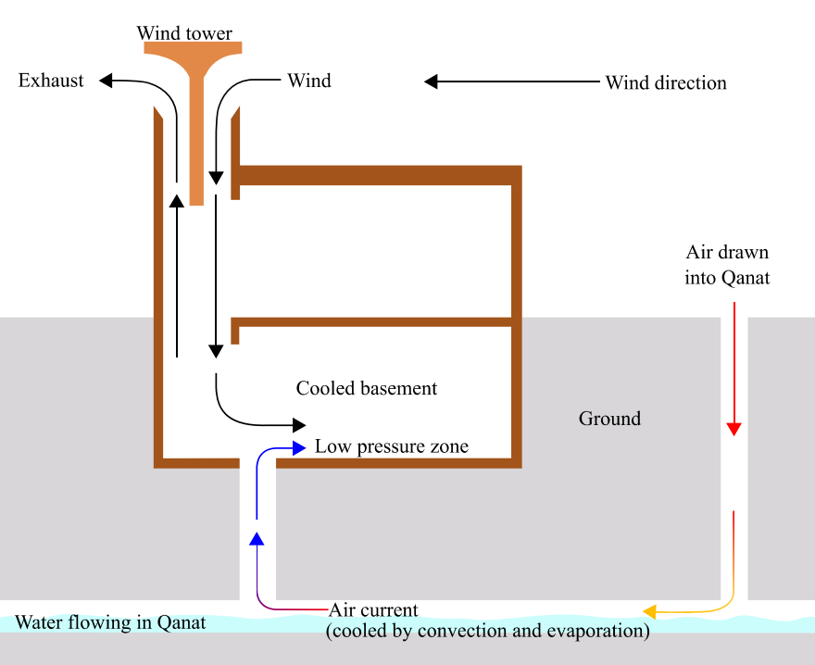

Excess heat stress is making India’s cities unlivable, making it crucial to design ways to adapt to high urban temperatures. The problem is especially acute in low-income communities in India, where houses are often constructed with materials that absorb heat and require more energy to cool down. These households often use cooling fans and air coolers for hours a day in the summer, raising their energy bills.

These homes, by shifting to passive cooling, could better adapt to days of extreme heat, making households less vulnerable to weather impacts and improving their resilience against climate change risks.

A vast majority of slum dwellers work outdoors and often don’t have proper cooling systems at home either. According to a focus group studies done by MHT (Mahila Housing Trust, an NGO promoted by SEWA) “the productivity of women staying home-based workers, who mostly work in afternoons could also go down sometimes up to 50% in summers resulting in reduced household incomes and increased financial burden.”

The MHT team came across Modroofs in 2012, when a mutual associate introduced them to Hasit Ganatra, founder of sustainable roofing firm Rematerials. Modroofs is a signature product of Rematerials, water-proof modular roofs made of paper waste and coconut husk that reduces the temperature of homes and provides an eco-friendly alternative to RCC roofs. They are also easily dismantled and reinstalled easily.

As the data gathered showed that temperatures indeed dropped, and by a substantial 7-8 degree Celsius, the MHT team offered feedback to refine the product and suit their requirements. Besides Modroofs, the NGO also offers Air Lite ventilators, made from fibre sheet to improve air circulation in homes. These ventilation systems also lower temperature, filter natural light better thus reducing electricity consumption and helps with indoor pollution.

Another heat-resilient solution that has found takers is the Cool Auto rickshaw. A layer of paddy husk, a traditional cooler used in many parts of India, is installed on the roof and outer walls of auto rickshaws. Using bamboo or plastic pipes, a frame is created overhead for the cooler’s placement, which brings down the temperature by 2-6 degree Celsius.

Simple and sustainable, these cooling initiatives can not only bring comfort in the lives of underprivileged communities in the midst of unforgiving summers, but also makes a positive impact on the environment.

REFERENCES

1. https://www.researchgate.net/publication/342389585_Validated_Simulation_of_Low_Cost_Thermal_Envelope_Upgrades_for_Slum_Housing/figures?lo=1
2. https://www.researchgate.net/publication/312432251_An_overview_of_passive_cooling_techniques_in_buildings_Design_concepts_and_architectural_interventio ns
3. https://tcd.uchicago.edu/projects/cool-roofing-solutions-reducing-heat-stress-in-delhi-slums/